links-

1. MODIFY any SOFT link and observer original?

**Soft Links will also get modified, if we modify the original file.**



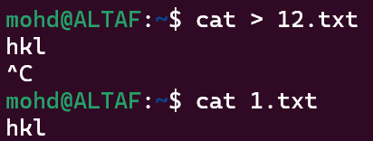

1. MODIFY original file of SOFT link and observe?

If we modify to original file soft link it effects on soft links

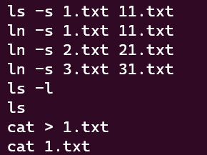

**.**

1. Remove any SOFT link and observer original?

**If we remove the soft link, the original file will still be available.**

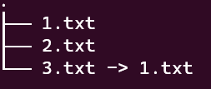

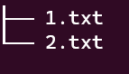

1. Remove original file of SOFT link and observe?

If we remove original file of soft link, soft links are invalid



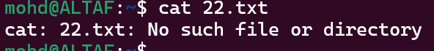

----

1. MODIFY any HARD link and observer original?

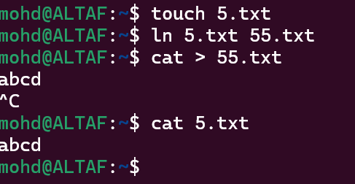

1. MODIFY Original file of HARD link and observe?

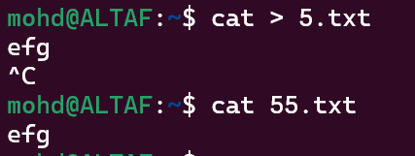

1. Remove any HARD link and observer original?

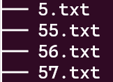

After removing hardlink(56.txt) it does not effects on original file

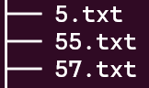

1. Remove original file of HARD link and observe?

Removed original file of hard link(5.txt)

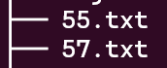

---

Comparision among soft,hard,copy?

**Comparison among soft, hard, copy?**

|  |  |
| --- | --- |
| Hard link | Soft link |
| It has the same inode number | It has different inode number |
| Changes made in any file will reflect all files | If the original file gets deleted, the soft link will also get deleted |
| It acts as a copy of a selected file | Acts as a reference to the file name |
| If we change the permissions on the source file, the same permission will be applied to the hard link file as well. | Soft links and source file will have different permissions |

---

what are wget , curl commands differences?

Wget

* Wget is a tool to download files from servers.
* Wget or GNU wget is another open-source free command-line tool

for transferring files using HTTP/HTTPS, FTP, and FTPS.

* The name is a combination of **World Wide Web** and the word **get**.

Curl

* Curl is a tool that exchange request/response with a server.
* Curl is a free and open-source command-line utility tool that allows the users

as well as the developers to transfer data without any UI interaction. It is

commonly used in routers, mobiles, etc.

-----

Scripts-

1. write a script to print the date and redirect it to output.txt?





1. create a file or folder using the date as the name?



1. i) Create a bash script to print the local time, date, username of your system, and your

current path.



ii) After printing, redirect the output into a file called output.txt

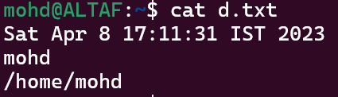

iii) Insert output.txt into a new directory, where the directory name is the current timestamp.



1. Create a bash script to execute the date every 2 minutes once on Saturdays only.



Crontab service



1. Take a backup of a folder every month twice?



1. Print the count of the number of files in a file called count.txt?

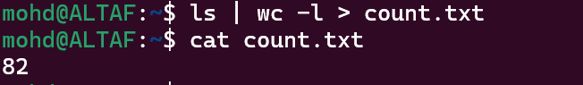

1. Create files dynamically every day at 12 AM where the file name is a date?



Crontab service to schedule job to create file dynamically everyday at 12 AM



CRONTAB SCRIPTS LABS:

1. Write a script to print the current directory and username and redirect it to a file called output.txt?



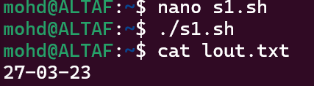

1. Create a file with the current timestamp as its name inside a folder with the current date as its name?



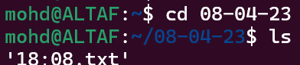

1. Create a bash script to print the local time, date, username of your system, and your current path and redirect the output into a file called output.txt. Insert output.txt into a new directory, where the directory name is the current timestamp.



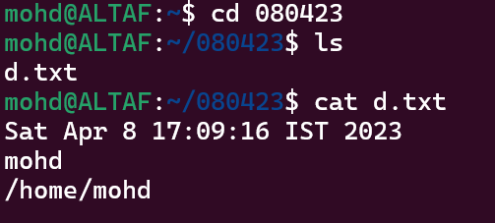

4. Write a script to print the count of the number of files in a folder and redirect the count to a file called count.txt.

(Reference: Google about word count and pipe commands in Linux)

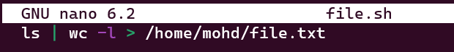

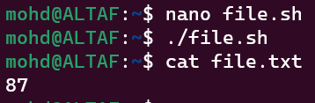

1. Create a bash script to execute the date every 2 minutes once on weekends only?

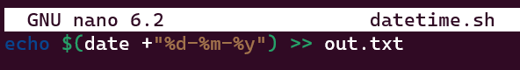

Crontab service for bash script to execute the date every 2 minutes once on weekends



6. Take a backup of a folder daily twice?

